USER GUIDE FOR 8051 DEVELOPMENT KIT

The 8051 Development Kit is a multipurpose kit. It can be used to run various 8051 programs and burn them into the microcontroller. It can also be used in practical Robotic/Automation applications where implementation of Actuators and Sensors may be required.

The development kit provided by us is shown below with the different parts labeled.

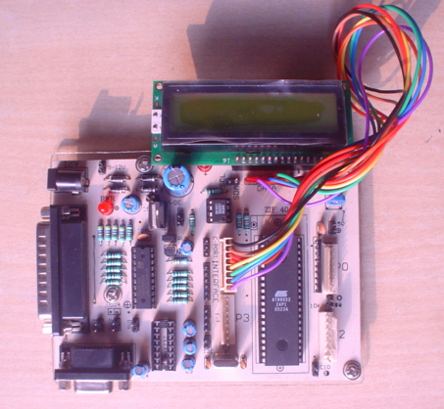
10
1
4
5
3
2
6
7
8
9
18
19
12 11 13
15
14
17
16

PLC INSTITUTE OF ELECTRONICS
www.plcie.com email id – plcie@rediffmail.com ph no.: 9312256415/9899893080
- AT89S52 Microcontroller
- Port 0 Connector
- Port 1 Connector
- Port 2 Connector
- Port 3 Connector
- 5V Power Supply Connector
- 5V Power Supply Connector
- Black Wire points to the LSB of each Port
- EEPROM 24Cxx (optional)
- LCD (optional)
- 5V Power Supply Connector
- 9 pin D-Shell Female Connector to get the input from the controller to the computer.
- MAX 232 for serial communication with PC ( optional )
- 25 pin D-Shell male connector to transfer the HEX code from PC to the microcontroller
- DC Jack for 12V Power supply
- Power Indication LED
- Buffer IC to toggle between the Programming mode and the Run mode
- Jumper
- LED that signifies whether the Jumper is connected or not

How to make the connections?

The adopter should be connected to the DC Jack (in the development kit) while the other end is to be connected with the AC supply. There is a 25 pin D-Shell Connector in the development kit that is to be connected with the parallel port of the PC through a cable. The corresponding LED on the development kit will indicate the supply of power or the successful connection of the kit with the PC.
Any kind of peripheral, as per the application, can be connected to the four Ports.
On programming the microcontroller correctly the peripherals will follow the desired output.

IMPORTANT NOTE: Any input or output pin should NOT be connected with the V_{cc} (5V Supply) directly.

PLC INSTITUTE OF ELECTRONICS
www.plcie.com email id – plcie@rediffmail.com ph no.: 9312256415/9899893080

Peripherals That Can Be Connected

- Seven Segment
- LCD (Liquid Crystal Display)
- LED (Light Emitting Diode)
- Actuators (along with their driver circuitry like H-Bridge)
- DC Motor
- Stepper Motor
- Limit Switch
- ADC (Analog to Digital Converter)
- DAC (Digital to Analog Converter)
- Proximity Sensors
- Metal Proximity Sensor
- Infra-Red Proximity Sensor
- Magnetic Proximity Sensor
- Ultrasonic Proximity Sensor
- DTMF (Dual Tone Multiple Frequency) Decoder- used especially for wireless control
- Matrix Keyboard
- Any electrical home appliances to be switched ON/OFF

Troubleshooting

- If the development kit is not working then
- Check if the connector of the 12V adopter is connected properly
- Check if the 25 pin D-Shell connector is connected properly
- If still the program is not able to burn then either the microcontroller is faulty or under rare circumstances the buffer IC is faulty.

- If the program is able to burn, but not able to run, then it means that the jumper near the 5V supply is not connected properly. If the jumper is connected properly then the LED (marked 19 in the diagram above) will glow.

- Select the correct device (AT89S52) in the SpiPgm uploader.
PLC INSTITUTE OF ELECTRONICS
www.plcie.com email id – plcie@rediffmail.com ph no.: 9312256415/9899893080

